Hello,
Can you please help us with more information which will help us build your website.

✅ BASIC BRAND

Final Brand Name ARWAADA BRIGHT MINDS

Tagline (if any) RIGHT GUIDANCE, RIGHT SKILLS, RIGHT FUTURE

Short About Brand (5–6 lines): At Arwaada Bright Mind , we help students , and working Professional to understand their potential, make informed career choices and learn with confidence

✅ SERVICES

For each main service:

Service Name
- AI Career Navigation
Psychometric & AI- assisted Career Exploration for deeper self-understanding and clarity for tomorrow., We guide to discover right academic and career pathways.
- Online Tutoring
Designed to strengthen concepts and improve academic performance. Special focus on academically weak students.
All subjects for class 1 to 5th ( all boards)
Maths & Science for class 6th,7th and 8th

Online / Offline / Hybrid : online

✅ ABOUT FOUNDER

Full name : ZEENAT
Zeenat is a seasoned education professional with over two decades of experience in academic leadership, student mentoring, curriculum management, and school administration across CBSE and preschool education. Known for her structured approach, empathetic counseling style, and commitment to student success, she has consistently guided learners toward academic excellence and personal growth.
Her counseling journey stems from extensive experience working closely with students and parents to address academic challenges, improve performance, and support informed educational and career decisions. She believes in creating a positive and engaging learning environment that empowers students to build confidence, discover their strengths, and achieve their fullest potential.

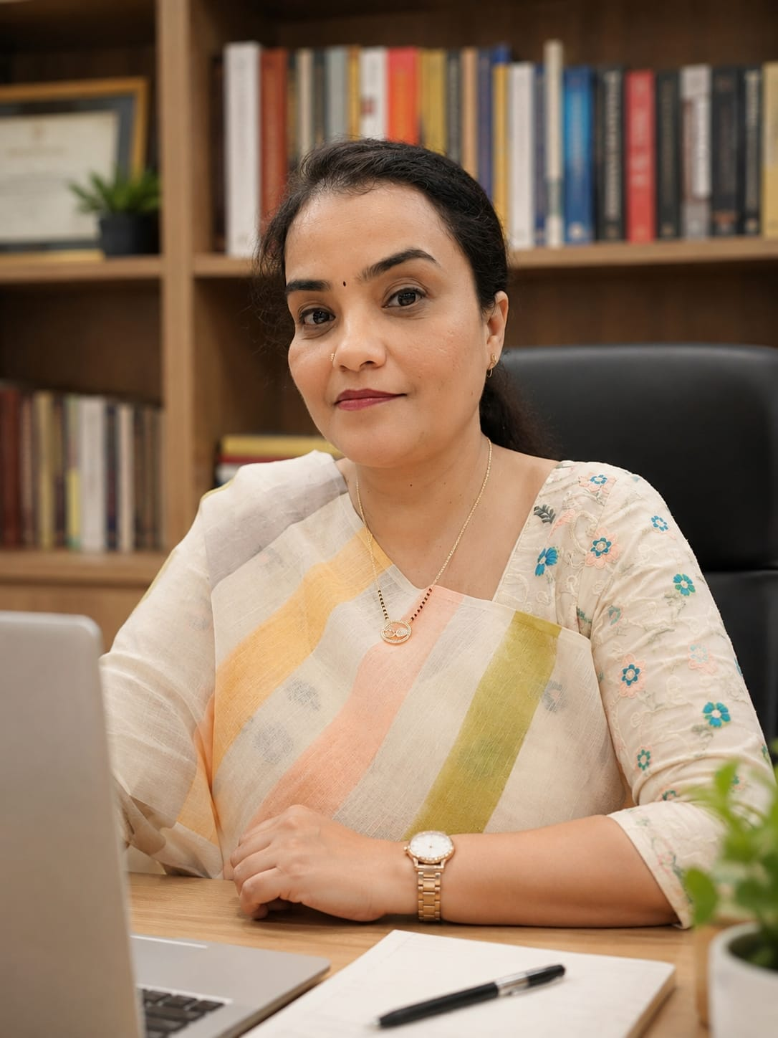

✅ SOCIAL PROOF

✅ CONTACT DETAILS

Phone / WhatsApp : 9899271800

Email zeeniali786@gmail.com

Office location (if any): NA

✅ MEDIA FILES

Logo (if available) :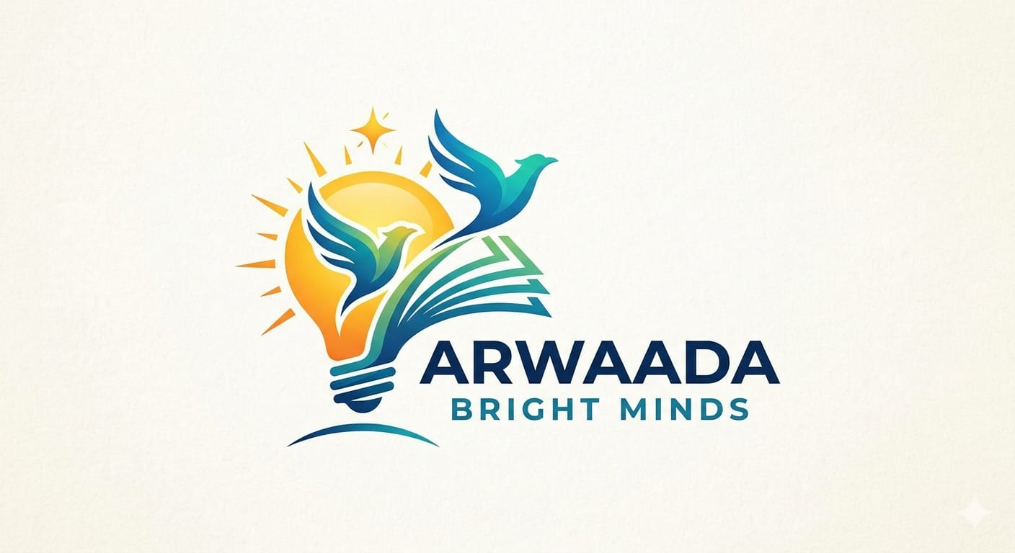

Brand colors (if any) Pastels

Images (events / sessions / workshops) NA

✅ SOCIAL LINKS

Instagram : https://www.instagram.com/arwaada.3112?igsh=MXkwZ2IycDgxNmlocQ==&utm_source=ig_contact_invite

LinkedIn
https://www.linkedin.com/in/zeenat-b4449718?utm_source=share_via&utm_content=profile&utm_medium=member_android

YouTube (if any)

Thank you.

